LAB ASSIGNMENT – 14.4 ( 2403A52398 )
Prompt 01:
Create a simple webpage with a header, main content, and footer.
Make it responsive using HTML and CSS so it looks good on mobile and desktop.
code:
<!DOCTYPE html>
<html lang="en">
<head>
<meta charset="UTF-8">
<meta name="viewport" content="width=device-width, initial-scale=1.0">
<title>Simple Responsive Page</title>
<!-- Load Tailwind CSS -->
<script src="https://cdn.tailwindcss.com"></script>
<!-- Configure Tailwind to use Inter font -->
<script>
tailwind.config = {
theme: {
extend: {
fontFamily: {
sans: ['Inter', 'sans-serif'],
},
},
},
}
</script>
<style>
/* A simple style block for demonstration, though Tailwind handles most of this */
body {
font-family: 'Inter', sans-serif;
}
</style>
</head>
<body class="flex flex-col min-h-screen bg-gray-50 text-gray-800">

<!-- Header Section -->
<header class="bg-gray-800 text-white p-6 shadow-md">
<div class="container mx-auto max-w-6xl">
<h1 class="text-3xl font-bold text-center md:text-left">My Website</h1>
</div>
</header>

<!-- Main Content Section -->
<!-- 'flex-grow' makes this section expand to fill available space -->
<main class="flex-grow container mx-auto max-w-6xl p-6">
<h2 class="text-2xl font-semibold mb-4">Main Content Area</h2>

<p class="mb-4">
This is a simple responsive webpage. The header is at the top, the footer is at the bottom,
and this is the main content area.
</p>

<!-- Removed the responsive grid to make it simpler -->
<div class="bg-white p-6 rounded-lg shadow-md">
<h3 class="text-xl font-semibold mb-2">Simple Section</h3>
<p>
This is a single content box.
</p>
</div>

</main>

<!-- Footer Section -->
<footer class="bg-gray-200 text-gray-600 p-6 text-center">
<div class="container mx-auto max-w-6xl">
<p>&copy; 2025 My Website. All rights reserved.</p>
</div>
</footer>

</body>
</html>

Preview:

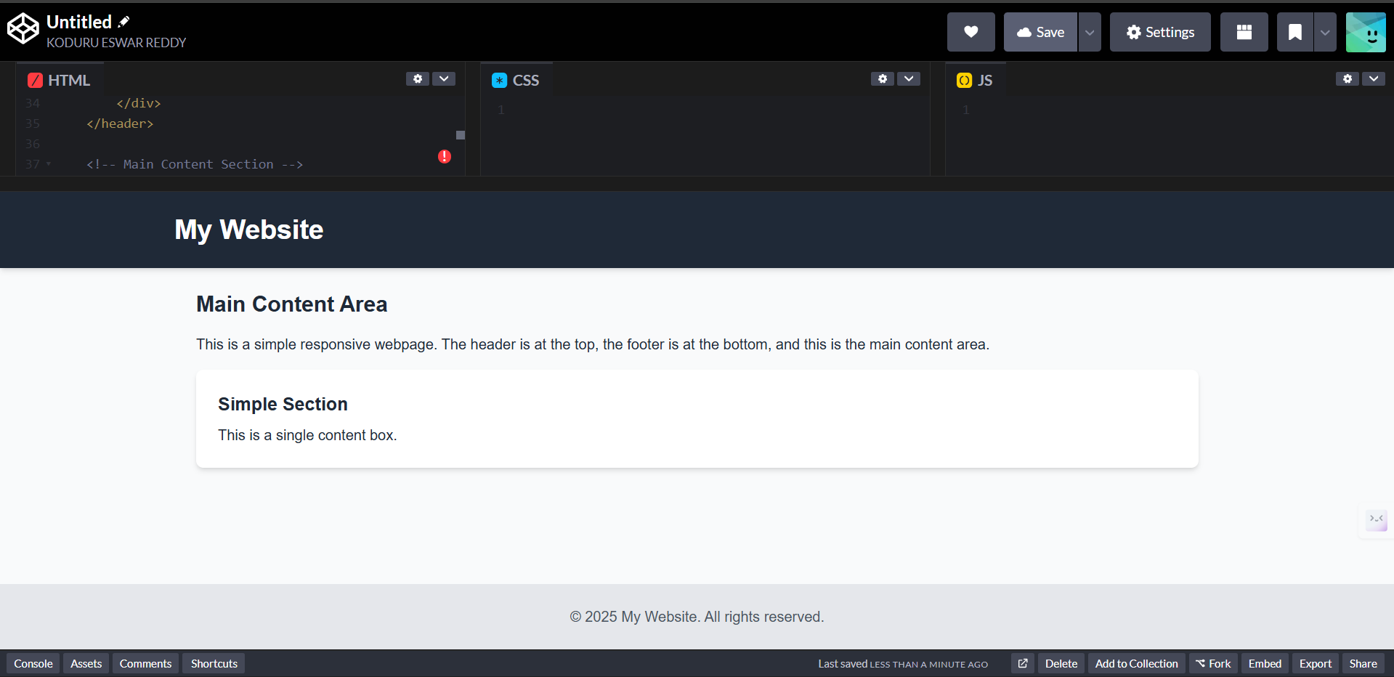
Prompt 02:
Make a button using HTML and JavaScript.
When clicked, show a message like “Button clicked!” using an alert
Code:
<!DOCTYPE html>
<html lang="en">
<head>
<meta charset="UTF-8">
<meta name="viewport" content="width=device-width, initial-scale=1.0">
<title>Simple Page</title>
<!-- Load Tailwind CSS -->
<script src="https://cdn.tailwindcss.com"></script>
<style>
/* Basic font styling */
body { font-family: sans-serif; }
</style>
</head>
<body class="bg-gray-50 text-gray-800">

<!-- Header Section -->
<header class="bg-gray-800 text-white p-4 text-center">
<h1 class="text-2xl font-bold">My Website</h1>
</header>

<!-- Main Content Section -->
<main class="p-4">
<h2 class="text-xl font-semibold mb-2">Main Content</h2>

<!-- Simple section with a button -->
<div class="bg-white p-4 rounded shadow">
<p class="mb-4">Click the button below!</p>

<!-- Button -->
<button id="mainButton" class="px-4 py-2 bg-blue-600 text-white rounded hover:bg-blue-700">
Click Me
</button>

<!-- Message will appear here -->
<p id="messageArea" class="mt-4 font-semibold text-blue-700"></p>
</div>

</main>

<!-- Footer Section -->
<footer class="bg-gray-200 text-gray-600 p-4 text-center mt-6">
<p>&copy; 2025</p>
</footer>

<!-- JavaScript for the button -->
<script>
// Get references to the elements
const mainButton = document.getElementById('mainButton');
const messageArea = document.getElementById('messageArea');

// Show a message when the main button is clicked
mainButton.addEventListener('click', () => {
messageArea.textContent = 'Button clicked!';
});
</script>

</body>
</html>
Preview:
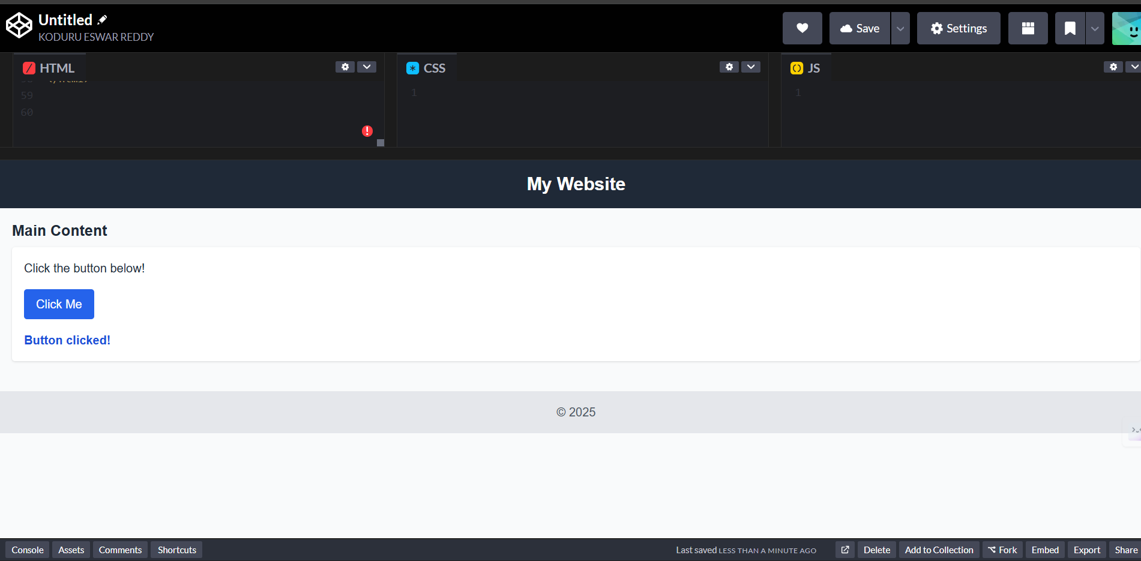
Prompt 03:
Create a contact form with Name, Email, and Message fields.
Use JavaScript to check if all fields are filled and email is valid.
Show a success message when the form is correct.
Code:
<!DOCTYPE html>
<html lang="en">
<head>
<meta charset="UTF-8">
<meta name="viewport" content="width=device-width, initial-scale=1.0">
<title>Simple Page</title>
<!-- Load Tailwind CSS -->
<script src="https://cdn.tailwindcss.com"></script>
<style>
/* Basic font styling */
body { font-family: sans-serif; }
/* Simple style for invalid fields */
.invalid-field {
border-color: #ef4444; /* red-500 */
}
</style>
</head>
<body class="bg-gray-50 text-gray-800">

<!-- Header Section -->
<header class="bg-gray-800 text-white p-4 text-center">
<h1 class="text-2xl font-bold">My Website</h1>
</header>

<!-- Main Content Section -->
<main class="p-4">

<!-- Simple section with a button -->
<div class="bg-white p-4 rounded shadow mb-6">
<h2 class="text-xl font-semibold mb-2">Simple Example</h2>
<p class="mb-4">Click the button below!</p>

<!-- Button -->
<button id="mainButton" class="px-4 py-2 bg-blue-600 text-white rounded hover:bg-blue-700">
Click Me
</button>

<!-- Message will appear here -->
<p id="messageArea" class="mt-4 font-semibold text-blue-700"></p>
</div>

<!-- New Contact Form Section -->
<div class="bg-white p-4 rounded shadow">
<h2 class="text-xl font-semibold mb-4">Contact Us</h2>

<!-- Contact Form -->
<!-- 'novalidate' stops the browser's default validation -->
<form id="contactForm" novalidate>
<div class="mb-4">
<label for="name" class="block mb-1">Name</label>
<input type="text" id="name" class="w-full px-3 py-2 border border-gray-300 rounded">
</div>

<div class="mb-4">
<label for="email" class="block mb-1">Email</label>
<input type="email" id="email" class="w-full px-3 py-2 border border-gray-300 rounded">
</div>

<div class="mb-4">
<label for="message" class="block mb-1">Message</label>
<textarea id="message" rows="3" class="w-full px-3 py-2 border border-gray-300 rounded"></textarea>
</div>

<button type="submit" class="w-full px-4 py-2 bg-green-600 text-white rounded hover:bg-green-700">
Submit
</button>
</form>

<!-- Form message area (for success or error) -->
<p id="formMessage" class="mt-4 font-semibold"></p>
</div>

</main>

<!-- Footer Section -->
<footer class="bg-gray-200 text-gray-600 p-4 text-center mt-6">
<p>&copy; 2025</p>
</footer>

<!-- JavaScript for the page -->
<script>
// === Button Click ===
const mainButton = document.getElementById('mainButton');
const messageArea = document.getElementById('messageArea');

mainButton.addEventListener('click', () => {
messageArea.textContent = 'Button clicked!';
});

// === Contact Form Validation ===
const contactForm = document.getElementById('contactForm');
const formMessage = document.getElementById('formMessage');

// Simple email check function
function isValidEmail(email) {
// A basic check for email format
return /^[^\s@]+@[^\s@]+\.[^\s@]+$/.test(email);
}

contactForm.addEventListener('submit', (event) => {
// Stop the form from submitting
event.preventDefault();

// Get the form fields
const name = document.getElementById('name');
const email = document.getElementById('email');
const message = document.getElementById('message');

// Reset styles and message
formMessage.textContent = '';
name.classList.remove('invalid-field');
email.classList.remove('invalid-field');
message.classList.remove('invalid-field');

let isValid = true;

// Check if fields are empty
if (name.value.trim() === '') {
name.classList.add('invalid-field');
isValid = false;
}
if (message.value.trim() === '') {
message.classList.add('invalid-field');
isValid = false;
}
// Check email
if (email.value.trim() === '' || !isValidEmail(email.value.trim())) {
email.classList.add('invalid-field');
isValid = false;
}

// Show success or error message
if (isValid) {
formMessage.textContent = 'Success! Your message was sent.';
formMessage.className = 'mt-4 font-semibold text-green-600';
contactForm.reset(); // Clear the form
} else {
formMessage.textContent = 'Please fill out all fields correctly.';
formMessage.className = 'mt-4 font-semibold text-red-600';
}
});
</script>

</body>
</html>
preview:
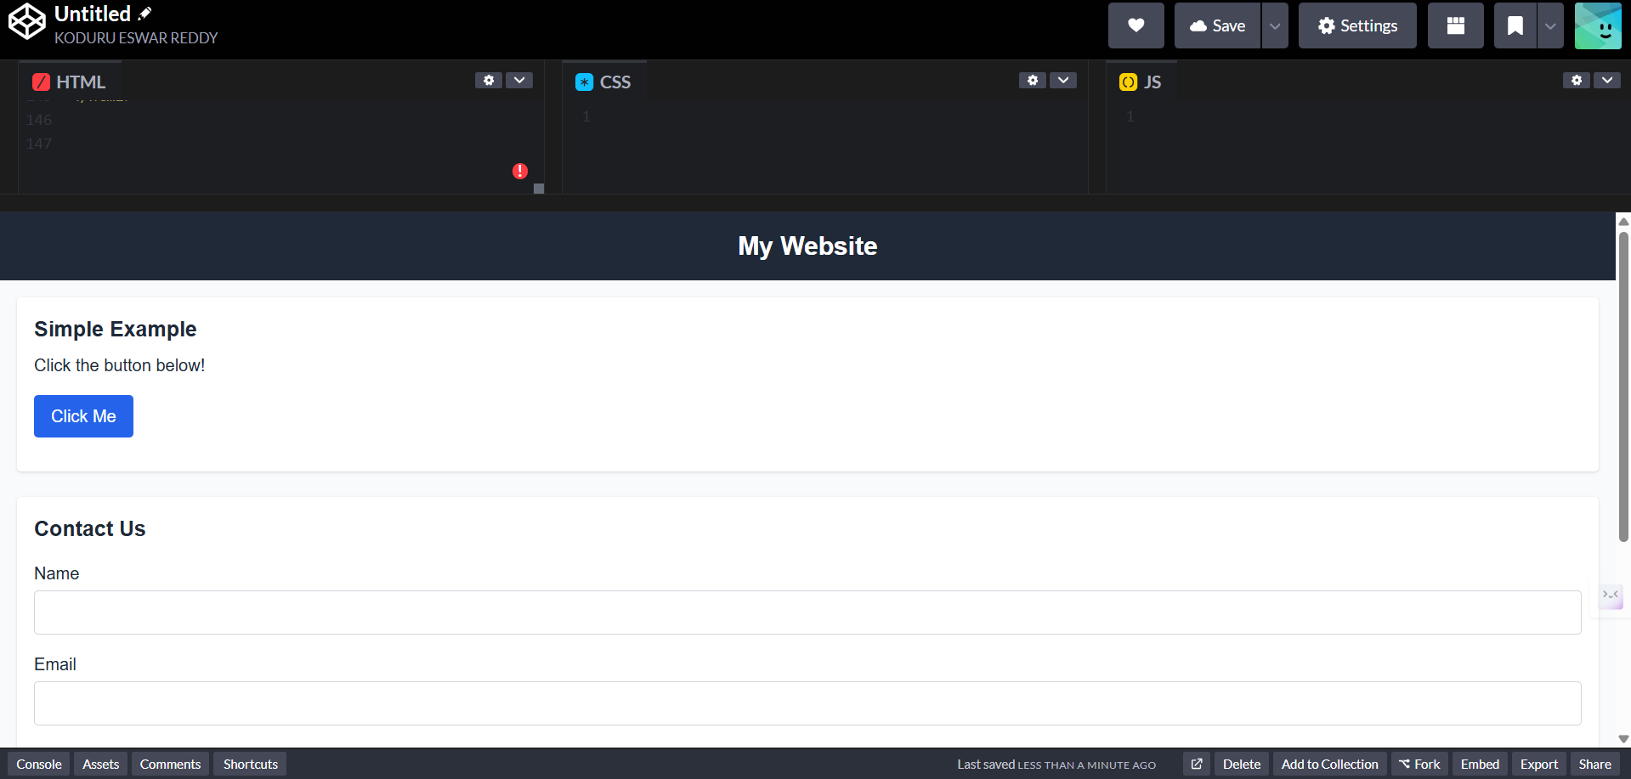
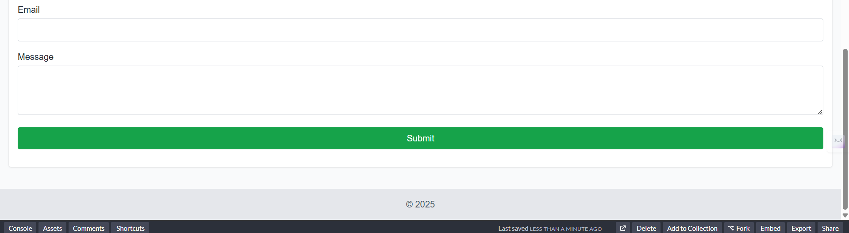

Prompt 04:
Make a list of items on a webpage.
Add two buttons one to add a new item and another to remove the last item using JavaScript.
Code:
<!DOCTYPE html>
<html lang="en">
<head>
<meta charset="UTF-8">
<meta name="viewport" content="width=device-width, initial-scale=1.0">
<title>Simple Page</title>
<!-- Load Tailwind CSS -->
<script src="https://cdn.tailwindcss.com"></script>
<style>
/* Basic font styling */
body { font-family: sans-serif; }
</style>
</head>
<body class="bg-gray-50 text-gray-800">

<!-- Header Section -->
<header class="bg-gray-800 text-white p-4 text-center">
<h1 class="text-2xl font-bold">My Website</h1>
</header>

<!-- Main Content Section -->
<main class="p-4">

<!-- New List Section -->
<div class="bg-white p-4 rounded shadow">
<h2 class="text-xl font-semibold mb-4">My List</h2>

<!-- Buttons for list manipulation -->
<div class="flex space-x-4 mb-4">
<button id="addItemButton" class="px-4 py-2 bg-blue-600 text-white rounded hover:bg-blue-700">
Add Item
</button>
<button id="removeItemButton" class="px-4 py-2 bg-red-600 text-white rounded hover:bg-red-700">
Remove Last Item
</button>
</div>

<!-- The list itself -->
<ul id="itemList" class="list-disc list-inside bg-gray-50 p-4 rounded border">
<li>First item</li>
<li>Second item</li>
</ul>
</div>

</main>

<!-- Footer Section -->
<footer class="bg-gray-200 text-gray-600 p-4 text-center mt-6">
<p>&copy; 2025</p>
</footer>

<!-- JavaScript for the page -->
<script>
// === List Manipulation ===
const addItemButton = document.getElementById('addItemButton');
const removeItemButton = document.getElementById('removeItemButton');
const itemList = document.getElementById('itemList');

// Keep track of how many items we have
let itemCount = 2; // We start with 2 items

// Add item
addItemButton.addEventListener('click', () => {
itemCount++; // Increment the counter

// Create a new list item element
const li = document.createElement('li');

// Set its text
li.textContent = 'New Item ' + itemCount;

// Add it to the list
itemList.appendChild(li);
});

// Remove last item
removeItemButton.addEventListener('click', () => {
// Find the last item in the list
const lastItem = itemList.lastElementChild;

if (lastItem) { // Check if a last item exists
// Remove it from the list
itemList.removeChild(lastItem);
itemCount--; // Decrement the counter
}
});
</script>

</body>
</html>
preview:
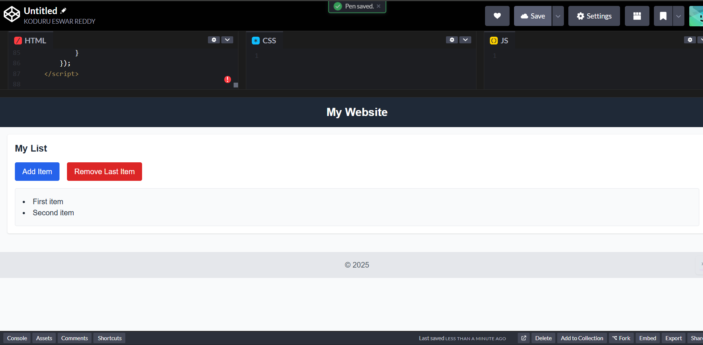
Prompt 05:
Create a button that opens a popup box (modal).
Add text inside the modal and a close (X) button to hide it.
Style it with CSS to look nice.
Code:
<!DOCTYPE html>
<html lang="en">
<head>
<meta charset="UTF-8">
<meta name="viewport" content="width=device-width, initial-scale=1.0">
<title>Simple Page</title>
<!-- Load Tailwind CSS -->
<script src="https://cdn.tailwindcss.com"></script>
<style>
/* Basic font styling */
body { font-family: sans-serif; }
</style>
</head>
<body class="bg-gray-50 text-gray-800">

<!-- Header Section -->
<header class="bg-gray-800 text-white p-4 text-center">
<h1 class="text-2xl font-bold">My Website</h1>
</header>

<!-- Main Content Section -->
<main class="p-4">

<!-- New Modal Button Section -->
<div class="bg-white p-4 rounded shadow mb-6">
<h2 class="text-xl font-semibold mb-4">Modal Example</h2>
<button id="openModalButton" class="px-4 py-2 bg-purple-600 text-white rounded hover:bg-purple-700">
Open Modal
</button>
</div>

<!-- List Section -->
<div class="bg-white p-4 rounded shadow">
<h2 class="text-xl font-semibold mb-4">My List</h2>

<!-- Buttons for list manipulation -->
<div class="flex space-x-4 mb-4">
<button id="addItemButton" class="px-4 py-2 bg-blue-600 text-white rounded hover:bg-blue-700">
Add Item
</button>
<button id="removeItemButton" class="px-4 py-2 bg-red-600 text-white rounded hover:bg-red-700">
Remove Last Item
</button>
</div>

<!-- The list itself -->
<ul id="itemList" class="list-disc list-inside bg-gray-50 p-4 rounded border">
<li>First item</li>
<li>Second item</li>
</ul>
</div>

</main>

<!-- Footer Section -->
<footer class="bg-gray-200 text-gray-600 p-4 text-center mt-6">
<p>&copy; 2025</p>
</footer>

<!-- The Modal -->
<!-- It's hidden by default with the "hidden" class -->
<div id="myModal" class="hidden fixed inset-0 bg-black/50 flex items-center justify-center p-4">
<!-- Modal content -->
<div class="bg-white rounded-lg shadow-xl p-6 w-full max-w-md relative">

<!-- Modal header with close button -->
<div class="flex justify-between items-center mb-4">
<h3 class="text-xl font-semibold">Modal Title</h3>
<!-- Close button (X) -->
<button id="closeModalButton" class="text-gray-500 hover:text-gray-800 text-3xl font-bold">&times;</button>
</div>

<!-- Modal body -->
<p>This is the content inside the modal popup box. You can put any text or HTML here.</p>
</div>
</div>

<!-- JavaScript for the page -->
<script>
// === List Manipulation ===
const addItemButton = document.getElementById('addItemButton');
const removeItemButton = document.getElementById('removeItemButton');
const itemList = document.getElementById('itemList');
let itemCount = 2;

addItemButton.addEventListener('click', () => {
itemCount++;
const li = document.createElement('li');
li.textContent = 'New Item ' + itemCount;
itemList.appendChild(li);
});

removeItemButton.addEventListener('click', () => {
const lastItem = itemList.lastElementChild;
if (lastItem) {
itemList.removeChild(lastItem);
itemCount--;
}
});

// === Modal ===
const openModalButton = document.getElementById('openModalButton');
const closeModalButton = document.getElementById('closeModalButton');
const myModal = document.getElementById('myModal');

// Show the modal
openModalButton.addEventListener('click', () => {
myModal.classList.remove('hidden');
});

// Hide the modal
closeModalButton.addEventListener('click', () => {
myModal.classList.add('hidden');
});

// Also hide modal if user clicks on the background
myModal.addEventListener('click', (event) => {
// Check if the click is on the background (myModal) and not on the content box
if (event.target === myModal) {
myModal.classList.add('hidden');
}
});
</script>
</body>
</html>
preview:
